WHITE STATION ELEMENTARY



ENTERING FIFTH GRADE

SUMMER PACKET

Name __________________________

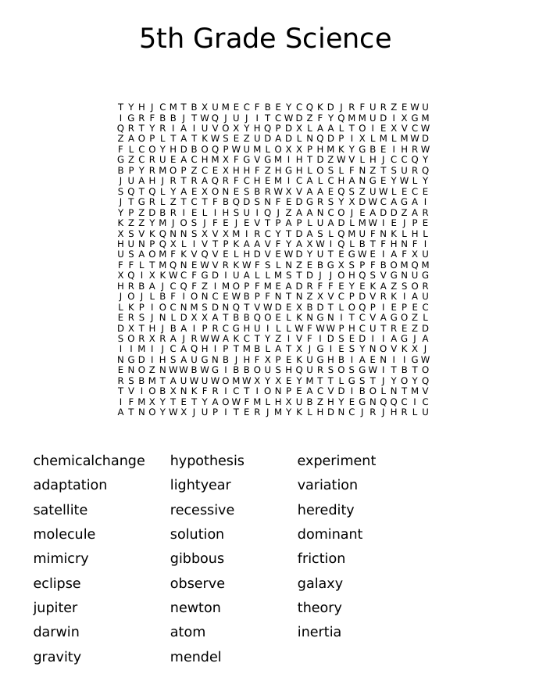

|  |
| --- |
| A black and white image of a book with glasses  Description automatically generatedWHAT IS MATTER AND  HOW DOES IT BEHAVE?  Look around you. Everything you can see is matter. This is the special name that scientists use to describe the stuff that everything is made of. Matter behaves and looks differently depending on many different factors. Over time, scientists have studied the behavior of matter. We now know a lot about how matter looks and behaves in different situations.  The States of Matter  All matter is made up of tiny, individual particles called atoms. These tiny atoms move and change their behavior which makes matter appear in different ways. The different forms in which matter appears are called the states of matter, which include solids, liquids, and gases.  Most things that we use on a daily basis are solids. This means that the particles are arranged in a fixed pattern and the atoms don't move very much. Solid matter can be strong or weak. For example, steel is known for being very strong. Other solids like wood or paper are weaker. However, in all cases, the particles are tightly bound together.  Liquids are different from solids because the atoms in this state of matter move around more freely. For this reason, liquids flow freely and change their shape depending on the shape of the container they are in. Although the atoms can move more freely than in solids, they are still linked together. You might imagine liquids like a string of beads that are all connected to each other. The most common liquid on Earth is water. However, most solids can turn into liquids through a process called melting. For example, many metals can be melted into liquids at very high temperatures.  Gases are the third state of matter. They are very light and float around. One gas you probably see regularly is water vapor floating out of a boiling pot of water. In this case, the atoms in the water begin moving more and more quickly and farther apart until they fly apart. The atoms in gases are free to move around and are no longer connected. For this reason, gases spread out into the container or space they're in. Gases can also be compressed. In this case, the atoms are pushed closer together.  Although you can't see gases, you can tell that they exist. For example, if you blow air into a balloon, you can see that the air fills up the balloon. YOU can see gas being compressed when you squeeze a part of the balloon and force the air into a smaller space. Other substances, besides air, that are gases are carbon dioxide, oxygen, hydrogen, and more.  Does Matter Disappear?  One important thing to know about matter is that it can never be created or disappear. No matter what changes you make to any type of matter, it will always exist. You can see this when matter changes state.  For example, if you weigh an ice cube and then wait until it melts, when you weigh the liquid water it will weigh the same amount as the ice cube. The same amount of matter exists whether the water is a frozen solid or liquid water. In another example, a piece of paper will weigh the same amount whether it's flat or crumpled up in a ball.  This idea that matter can't be created or destroyed is called the law of conservation of mass. It was discovered by Antoine Lavoisier in 1785.  Thanks to the work of many scientists, we now understand a lot about what matter is and how it behaves. Now, as you look around your world, try to notice which states of matter you can see and how they behave. |

l. What is matter?

2. What are solids? Give at least two examples, one from the text and one of your own.

3. What are liquids? Give at least two examples, one from the text and one of your own.

4. What are gases? Give at least two examples, one from the text and one of your own.

5. Can matter be created? Does matter disappear? Explain why or why not.

CHANGES IN MATTER

When you cook an egg, something that was once liquid turns into a solid.

Whether it's hard-boiled, scrambled, or fried, the egg changes permanently, The cooked egg is very different from the raw egg. Not only did it change states, but the particles are different, it has a new smell, and the transparent part turned white. Its properties are very different. Something new has been made.

What does baking have to do with science? Well, there's actually a lot of science involved in baking, including chemical changes in matter.

What does this mean? It means that cooking an egg is a chemical change.

In our everyday lives, matter changes all the time. It happens when you cut paper into pieces, when you boil water to make spaghetti, and when you bake a cake. Understanding these changes can help us better understand how matter behaves.

Properties of Matter

All matter has certain properties. Basically, these are ways you can describe or measure matter. Some examples are color, weight, size, or how hard it is. For example, some of the properties of paper might be that it's light, white, thin, and flexible. If you measure these properties, you will know more details about the paper. For example, some paper is thicker and heavier than other paper.

Another property of matter is solubility. This refers to whether or not you can dissolve the matter. For example, if you mix water and sugar together, the sugar dissolves into the water. It's soluble. When you mix something soluble with water, you make a solution.

However, making a water and sugar solution doesn't mean the sugar disappeared. Although you can't see it, it's still there. You can test this by weighing the sugar and water separately ahead of time, Then, when you weigh the solution of water and sugar, you'll find it weighs the same as the combined weight of the originally separate sugar and water. Another way to see that the sugar is there is by letting the water evaporate. After it does, the sugar will be left behind.

However, other things, like sand, are not soluble. No matter how long you try to stir sand into water, it won't dissolve. So, if you do mix sand and water together, this is a heterogeneous mixture. These mixtures can be separated with physical methods. In other words, you can use a sieve to filter the sand out of the water.

Chemical Vs. Physical Changes

When a change happens to matter, sometimes the properties change and sometimes they don't. For example, when you cook an egg, the properties change. When the properties change and a new substance is made, we call this a chemical change. Other signs of a chemical change are that the color changes, a gas or bubbles appear, a smell changes, or the temperature changes on its own.

However, in physical changes, the properties of the matter stay the same. No new substance is made. When matter changes state, this is also a physical change. For example, if an ice cube melts into water, this is a physical change. Another example of a physical change is if you cut paper. The properties of the paper remain the same. You might say that the paper seems to change size. However, if you put the pieces back together, the size is the same. On the contrary, if you burn paper, you make a gas and a new substance: ash. This is a chemical change.

When these cupcakes were baked, was new matter created? What happened to the ingredients?

Another example of a chemical change is when you mix baking soda and vinegar. As soon as you mix these items, frothy bubbles will appear. This shows that a gas has been created. In fact, you can see the gas if you put a small amount of vinegar in a bottle and put a balloon with baking soda over the mouth. Then, when you dump the baking soda from the balloon into the bottle, the balloon will inflate thanks to the newly created gas.

Matter is all around us and is always changing. Can you see some chemical or physical reactions happening in your house?

SCIENCE BOWL PREVIEW

1. The temperature at which a substance changes state from a gas to a liquid

* Melting point
* Condensation point
* Boiling point
* Freezing point

2. The temperature at which a substance changes state from a liquid to a solid.

* Melting point
* Condensation point
* Boiling point
* Freezing point

3. Who is a person that studies fossils?

* geologist
* paleontologist
* meteorologist
* pathologist

4. What material allows heat of electricity to pass through it?

* Conductor
* Insulator
* Compound
* Product

5. What is form of a trait that is hidden, or masked, in the hybrid generation?

* Dominant
* Recessive
* Genetics
* Reproduction

6. A __________________ is a mixture of ice, frozen gases, rock and dust left over from the formation of the solar system.

* asteroid
* comet
* black hole
* meteor

7. The temperature at which a substance changes state from a liquid to a gas

* Melting point
* Condensation point
* Boiling point
* Freezing point

8. What is the thick bundle of nerves inside the spine?

* skeleton
* bones
* spinal cord
* nebula

9. What is a change of matter in size, shape or state that does not change the type of matter?

* Chemical change
* Physical change
* Chemical reaction
* Solubility

10. What is a reaction or change in behavior of an organism to an unexpected stimulus?

* Reactant
* Response
* Stimulus
* Reflex

11. The temperature at which a substance changes state from a solid to a liquid

* Melting point
* Condensation point
* Boiling point
* Freezing point

12. What is an inherited behavior that is not learned but done automatically?

* learned behavior
* variation
* trait
* instinct

13. Everything that is made of matter has

* weight
* mass
* molecule
* compound

14. The distance light travels in a year

* light year
* lunar eclipse
* inertia
* orbit

15. What is an object in space that produces its own energy, including light and heat?

* star
* asteroid
* meteoroid
* comet

16. What is the upward push of a liquid or gas on an object placed on it?

* balanced forces
* density
* distillation
* buoyancy

17. ______________________ is when an object in motion (or rest) stays in motion (or rest), resisting change unless acted upon by an outside force.

* gravity
* inertia
* newton
* force

18. Anything that has mass and takes up space

* texture
* molecule
* matter
* particles

19. What is a set of organs that uses information from the senses to control all body systems?

* Central Nervous System
* Peripheral Nervous System
* Sensory Organs
* Circulatory System

20. What is the smallest unit of an element that has the properties of that element?

* Electron
* Molecule
* Neutron
* Atom

FIFTH GRADE SCIENCE TCAP PREVIEW

What causes the moon phases?

o The Earth revolving around the sun

o The moon revolving around the Earth

o The sun rotating around the Earth

o The Earth's rotation

When do lunar eclipses occur?

o new moon

o full moon

o waxing gibbous

o waning gibbous

What is the biggest cause of the tides on Earth?

o Sun's gravity

o Moon's gravity

o Earth's gravity

It takes _____________ for the moon to revolve around the Earth.

o 365 days

o 27 days

o 14 days

o 24 hours

The apparent movement of stars at night are caused by

o the rotation of the Earth

o the revolution if the Earth around the Sun

o The revolution of the stars around the Sun

o The revolution of the Sun around the galactic center

The apparent movement of the constellations throughout the year is caused by

o the rotation of the Earth

o the revolution if the Earth around the Sun

o The revolution of the stars around the Sun

o The revolution of the Sun around the galactic center

Seasons are caused by

o the revolution of the Earth around the Sun

o the tilt of the Earth's axis

o the revolution of the Earth around the Sun and the tilt of the Earth's axis

o the distance between the Sun and the Earth

Our galaxy (the Milky Way) is which kind of galaxy

o elliptical

o irregular

o spiral

Our galaxy is

o one of about 50 galaxies

o is the only galaxy

o is only one of billions of galaxies

o is the largest galaxy in the universe

The closer a planet is to the sun, the

o faster it rotates

o slower it rotates

o faster it revolves

o slower it revolves

This celestial body is like the others except it contains ice

o comet

o asteroid

o meteor

o meteorite

All the following are physical properties of substances except

o melting point

o color

o shape

o ability to burn

o phase shifting

All of these are chemical properties except

o reaction to heat

o boiling point

o ability to burn

o reactivity to other elements

o oxidation

________________ occur when matter changes into a new substance.

o Chemical change

o Physical change

All of these are signs of a chemical change except

o expected color change

o change in odor

o formation of a gas

o unexpected color change

o formation of a precipitate

Law of Conservation of mass states that matter cannot be created or destroyed. It can occur in

o chemical changes

o physical changes

o both

All of the following are instincts except

o fight or flight

o hibernating bears

o a baby crying

o a racoon dumpster diving

Which is an inherited physical trait?

o learning to read

o eye color

o hunting

o duck imprinting on a dog

An adaptation is

o a variation

o a variation that ensures survival

o a variation that ensures extinction

o a behavior only

Everything that is made of matter has mass. Everything that has mass has

o matter

o gravity

o weight

o newtons

Which two things are gravitational forces dependent on? [Select two

answers]

o distance between objects

o weight of objects

o mass of objects

o velocity of objects

o friction between objects

Weight is a unit of

o how much matter you are made of

o how much gravity is pulling on you

o velocity

A student stands on a scale, and the scale reads 100 pounds. What is being

measured by the scale?

o the air pressure surrounding the student

o the mass of the student

o the volume of the student

o the force of gravity acting on the student

You mass 45 kilograms on Earth.

o You would weigh 100 pounds in the moon

o You would mass 17 kilograms on the moon

o you would mass 45 kilograms on the moon

o you would weigh 45 pounds on the moon

Which of these will result in the most gravitational attraction?

o two 2-gram objects 2 meters apart

o two 2-gram objects 4 meters apart

o two 1-gram objects 6 meters apart

o two 1-gram objects 8 meters apart